**User Id retrieval from Siteminder to EMC Application**

Contents

Revision History 3

Objective 4

Synopsis 4

Changes in smauth project 5

Generate smauth.jar 6

Changes in EMC application 7

Troubleshooting 9

Sample java file for reference 10

# Revision History

|  |  |  |  |
| --- | --- | --- | --- |
| Date | Version | Description | Author |
| 23th April, 2016 | 1.0 | Initial draft version | Malik |
|  |  |  |  |
|  |  |  |  |

# Objective

Objective of this document is to provide information on the steps that need to be followed to retrieve the user id from site minder.

This guideline is applicable for EMC applications that need the user id to be retrieved from site minder.

# Synopsis

Following are the step to add the functionality to retrieve user id from site minder

* Apply changes in smauth project
* Generate smauth.jar
* Add smauth.jar to EMC application
* Apply changes to EMC application

***Note:***  *Before doing the changes, make sure the versions of JDK, JRE, DDS, xDB, GWT are same for both projects (EMC and smauth).*

# Changes in smauth project

1. Download the ***smauth project*** **<repository link to be added>**
2. Import to eclipse as Existing project.
3. Verify the directory locations available in **build.properties** file(in local) *\*locations may vary*

# Ant properties

xdb.home=C:/Work/Softwares/xDB

dds.lib=C:/Work/EMC/InfoArchive_AD-3.2/lib

gwt.lib=C:/Work/Softwares/gwt-2.7.0

1. In **build.xml** file, check the below script and verify the jar and their version. Make sure the mentioned jars are available in lib folder of smauth project

<path id="master-classpath">

<fileset dir="${dds.lib}">

<include name="dds-server_10.5.0.jar"/>

<include name="dds-gwt-server_10.5.0.jar"/>

</fileset>

<fileset dir="${lib.dir}">

<include name="xhive.jar"/>

</fileset>

<fileset dir="${gwt.lib}">

<include name="gwt-user.jar"/>

</fileset>

</path>

# Generate smauth.jar

1. Once changes are done in smauth project,

Select ***build.xml***, right click🡪Run As🡪2 Ant Build

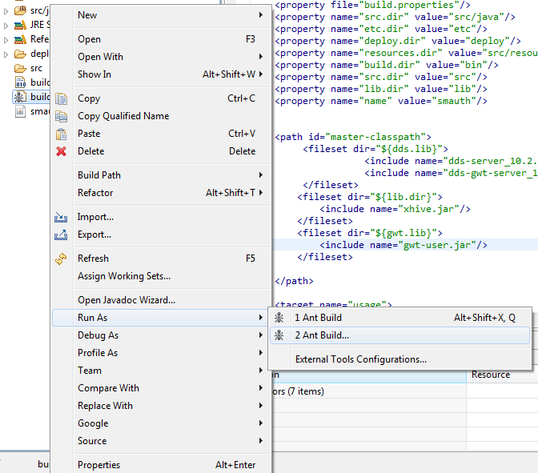

1. The target execution order should be ***Clean, Build, and Deploy*** (as shown below). Click on Apply and Run.

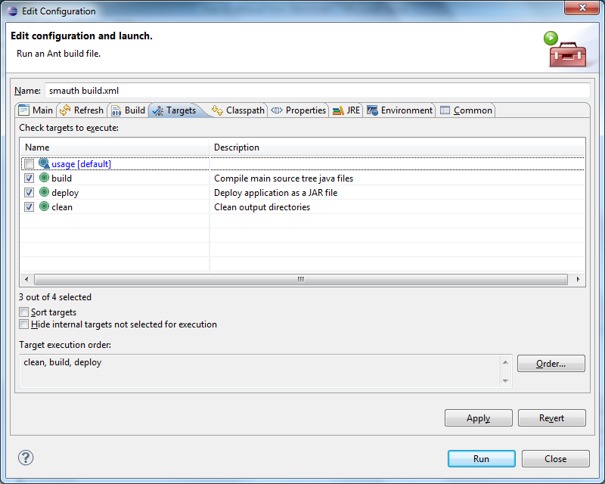

1. Once the build is successful, the ***smauth.jar*** will be generated at **smauth🡪deploy** directory
2. Use this generated jar file in the EMC application.

# Changes in EMC application

1. Open com.emc.dds.xmlarchiving.client.Main.java file.

We already have the below variable declaration.

private String userName;

Generate the Getters and Setters for the same.

**public** String getUserName() {**return** userName;}

**public** **void** setUserName(String userName) {**this**.userName = userName;}

1. Replace ***private void*** *onUserServiceConfigurationCheck() m*ethod with the following code

**private** **void** onUserServiceConfigurationCheck() {

**if** (userServiceConfigured) {

UserServiceAsync service = DDSServices.*getUserService*();

**final** Main mainWindow = **this**;

service.login("", "", **new** AsyncCallback<Boolean>() {

@Override

**public** **void** onFailure(Throwable caught) {showLogin();}

@Override

**public** **void** onSuccess(Boolean result) {

**if** (result.booleanValue()) {

**final** RoleServiceAsync roleService = (RoleServiceAsync) GWT.*create*(RoleService.**class**);

roleService.getRoleId(**new** AsyncCallback<String>() {

@Override

**public** **void** onFailure(Throwable caught) {FailureHandler.*handle*(**this**, caught);}

@Override

**public** **void** onSuccess(String roleId) {getRole(roleId);}

});

roleService.getUserId(**new** AsyncCallback<String>() {

@Override

**public** **void** onFailure(Throwable caught) {FailureHandler.*handle*(**this**, caught);}

@Override

**public** **void** onSuccess(String userId) {setUserName(userId);}

});

} **else** {showLogin();}

}

});

} **else** {

role = **new** Role(**new** ArrayList<Restriction>());

DDSServices.*getApplicationService*().getApplicationContext(

**new** RetrieveApplicationContextCallback());

}

}

1. Open ***com.emc.dds.xmlarchiving.client.ui.LogoutPane.java*** file.

Go to **public** LogoutPane(**final** Main main) Method.

Add below code after the Line.

HorizontalPanel headerPanel = **new** HorizontalPanel();

String uname = main.getUserName();

Label loggedInLabel = **new** Label("Currently logged in as " + uname + "\u00a0\u00a0");

HTML label = **new** HTML("<a>Logout</a>");

1. Replace the **LoginPanel.java** file with the one available in the last section (Sample java files for reference)
2. Create **smauth.properties** file.

Place below script in the file.

com.uhg.xmlarchiving.smauth.groupNames=HTTP_Archive-Guest-GS;HTTP_Archive-Admin-GS

com.uhg.xmlarchiving.smauth.useSiteMinder=true

The key com.uhg.xmlarchiving.smauth.groupNames holds all the application specific roles separated by semicolon. The role name must match the roles available in xDB for the selected application

1. Copy the **smauth.jar** from ***smauth/deploy*** directory and place it in ***<EMC application>/lib***Directory.
2. Then open the EMC project ***Build Path🡪Libraries***.

Select Add Jars 🡪 <EMC Application> 🡪 lib 🡪 smauth.jar.

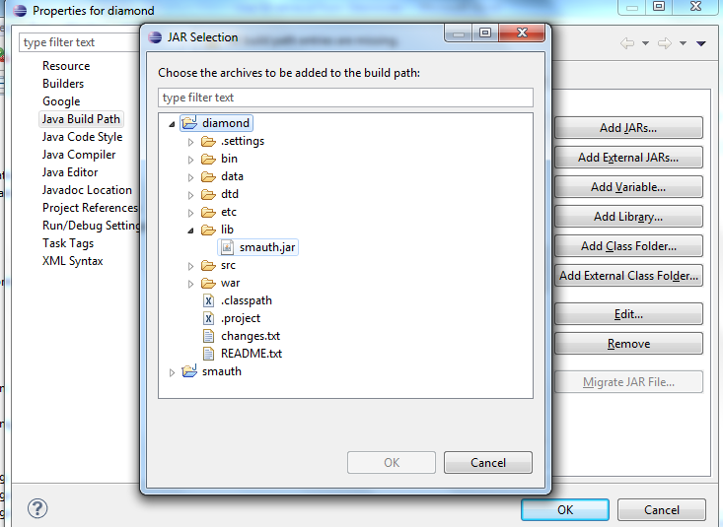

1. Clean and Build the application, then Run the Application
2. You should get your login UserName.

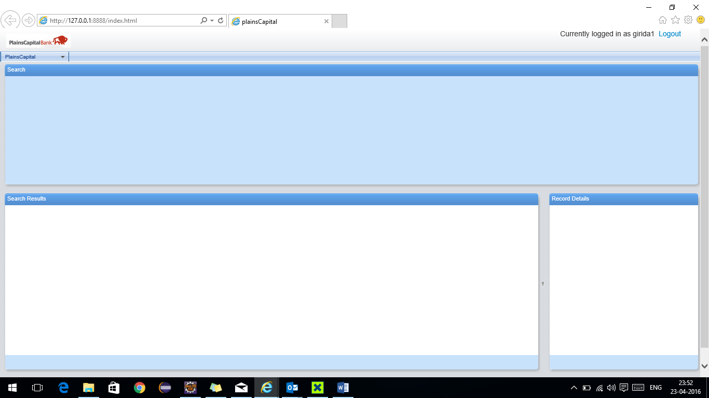

# Troubleshooting

1. Got below error **while generating smauth.jar.**

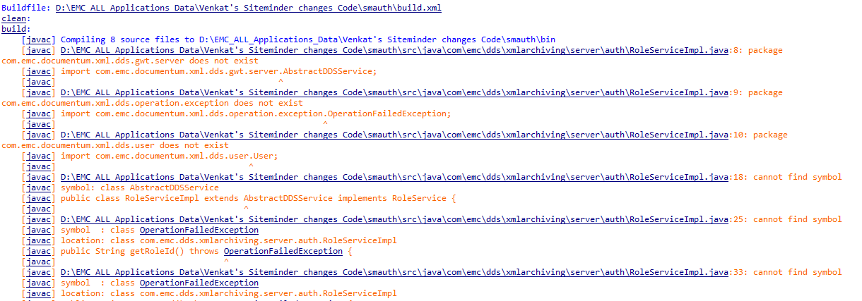

**Solution:** Place below jars in the smauth/lib directory and verify the versions of jar in build.xml.

*dds-server_10.5.0.jar*

*dds-gwt-server_10.5.0.jar*

*xhive.jar*

1. Got below error **while accessing application**.

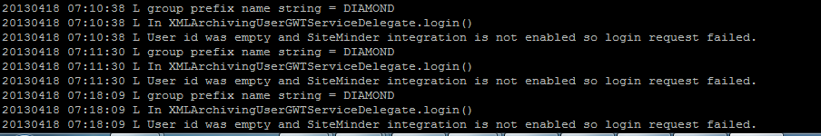

**Solution:** Follow point 4 in the previous section (Changes in EMC application)

# Sample java file for reference

